- Open the FBB3 game, verify the version is 3.0.29. If not, then download it and install it from here: http://www.fbbgames.com/FBPB3Update3029.exe
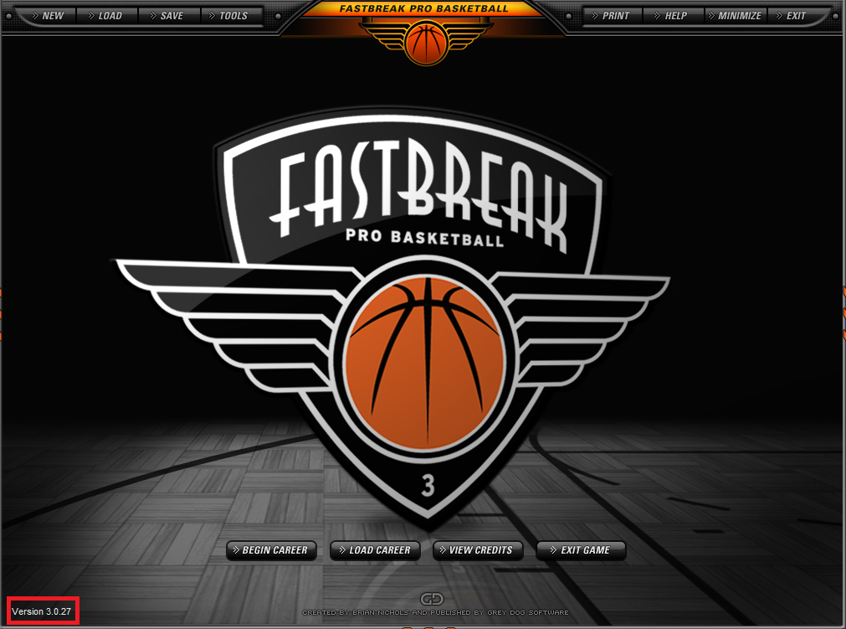
- Open the FBB3 game, click Begin Career.
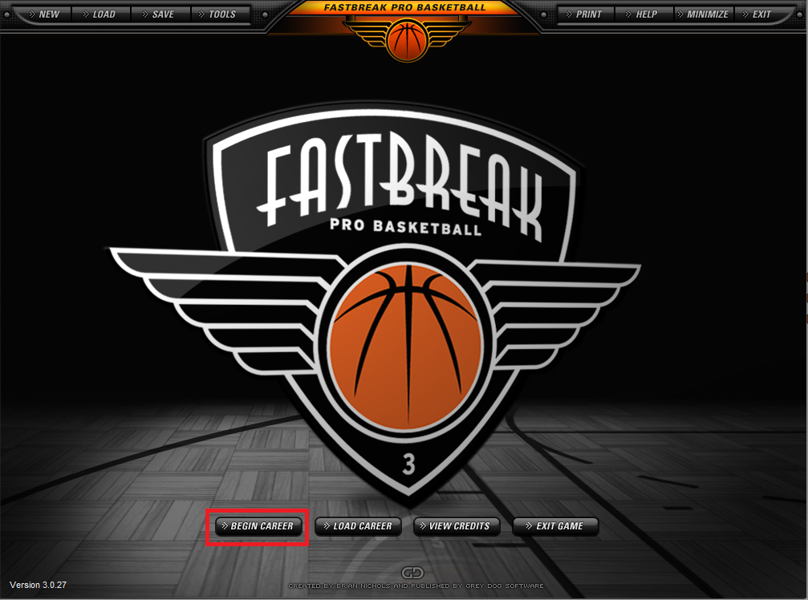
- Enter IFFBL in the league name at the top.
- Select any league at the bottom and click Activate.
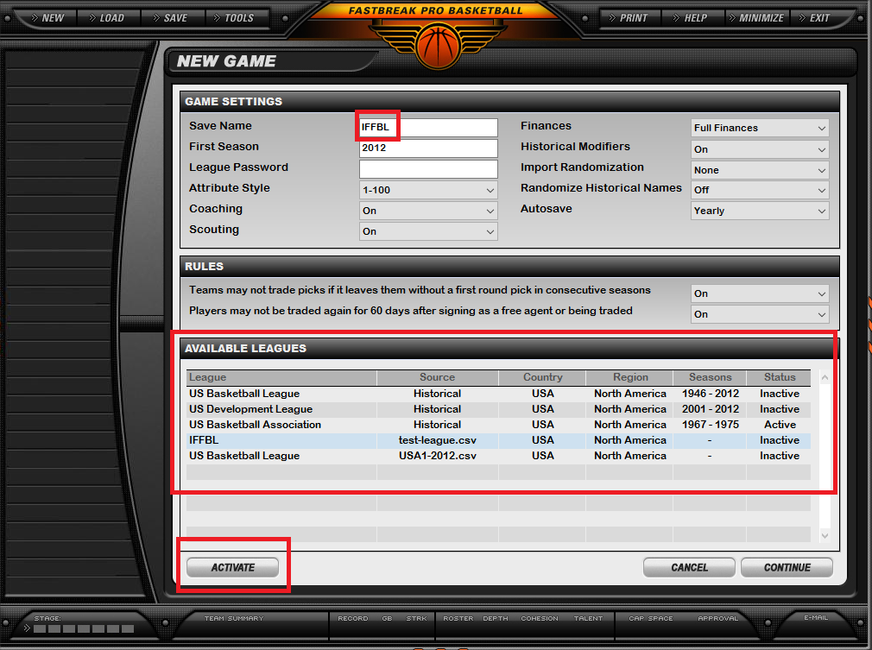
- Click continue.
- Click continue again.
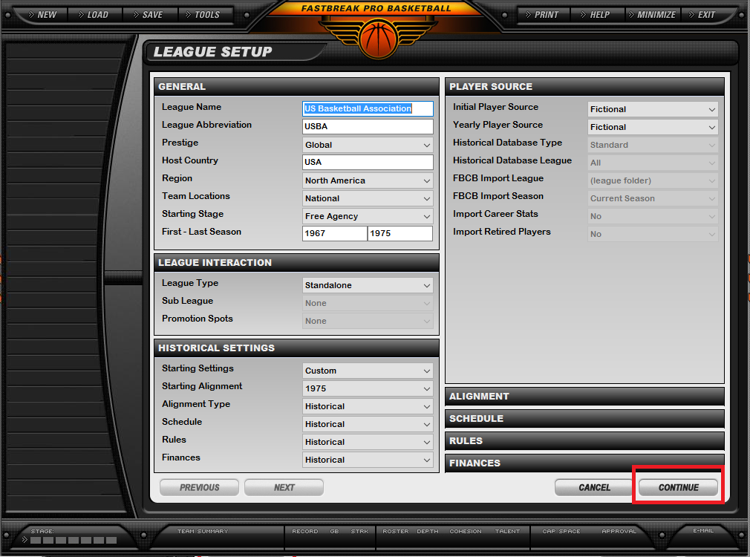
- After the new game is created, click the Save button at the top and exit FBB3.
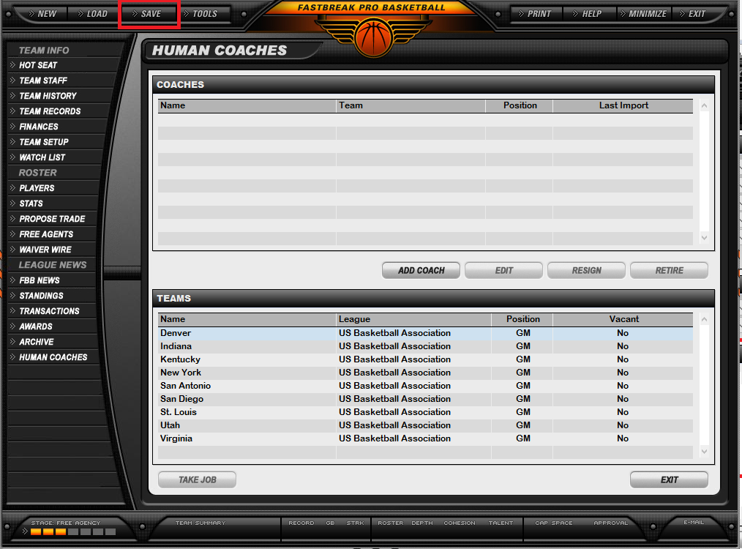
- Go to the league website which is www.iffbl.com.
- Go to the GM Tools drop-down and select File Manager.
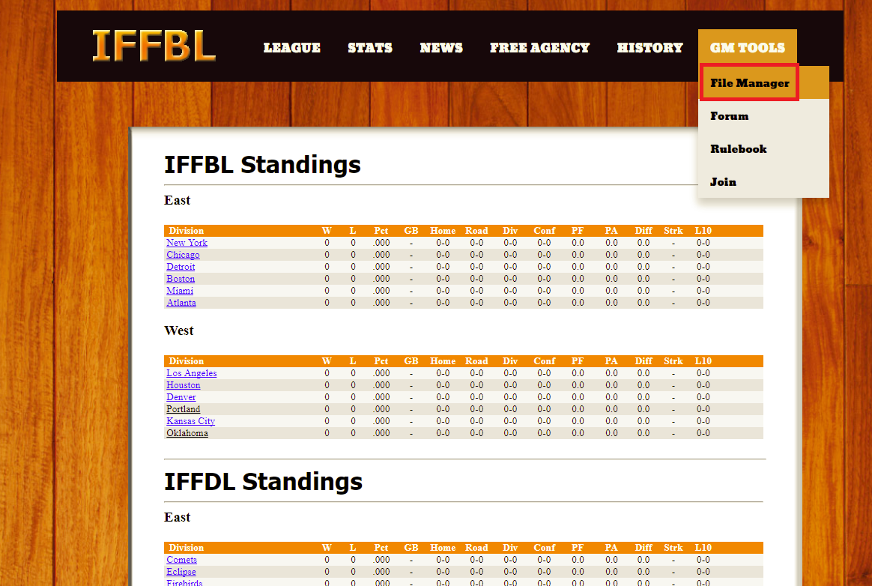
- Login with the File Manager credentials provided to you. It will have you change your password on first login.
- Under where it says League File, click the Download button.
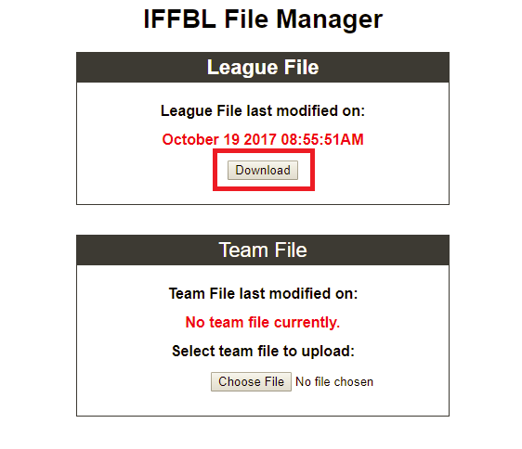
- Save the file to the league folder on your computer, which is C:\users\public\pubic documents\GDS\leaguedata\IFFBL).
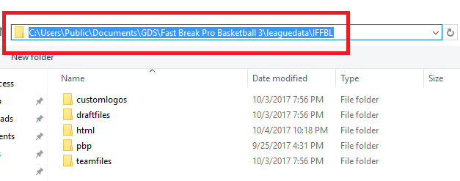
- Right-click the league file and choose EXTRACT HERE.
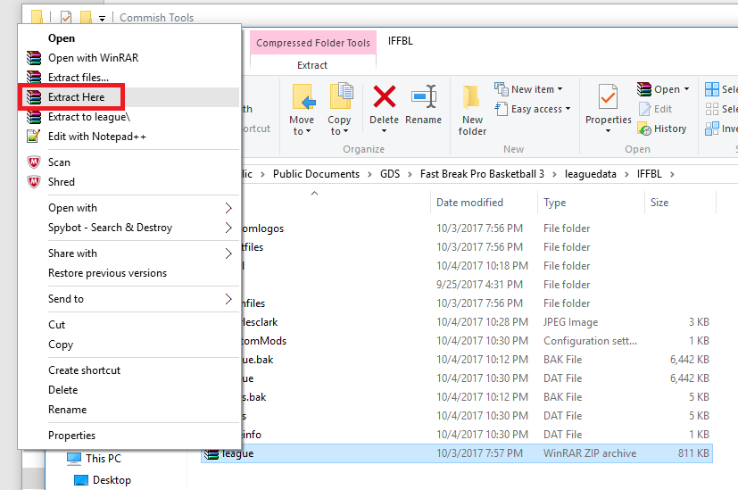
- Open FBB3, click Load and select the IFFBL game you created.
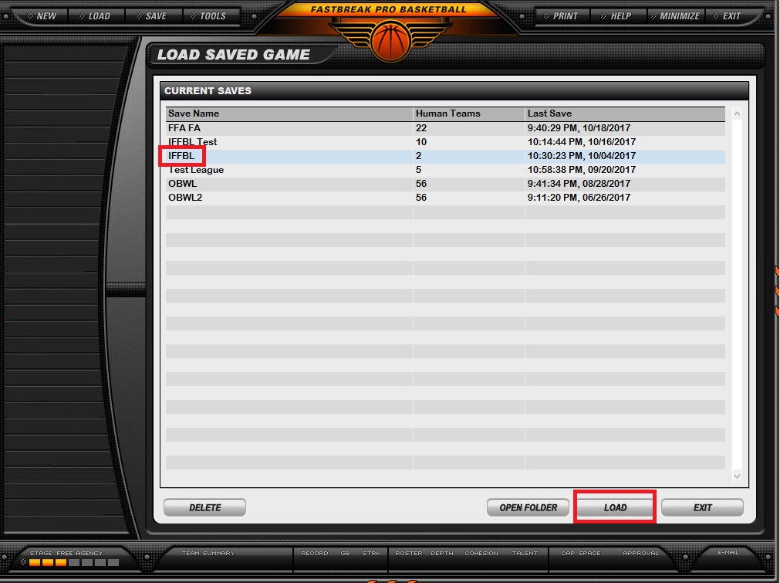
- Select your name from the drop-down.
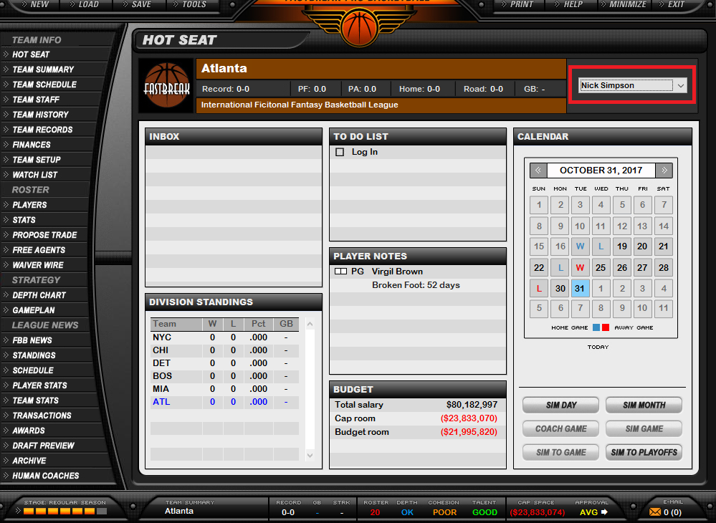
- Click the Log In button and enter the password that was provided to you for your team.
